EXP NO: 04 Memory Forensics with Volatality NAME : ADHIYAN PERIYAR R P

DATE: 31/07/2025 ROLL NO : 231901002

AIM:



Task 1 : Introduction



Task 2 : Volatility Overview



Task 3 : Memory Acquisition and Analysis

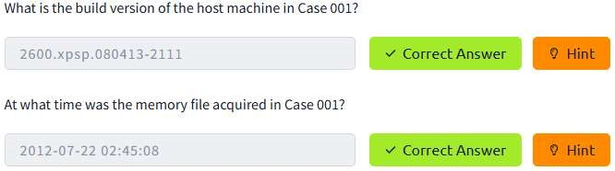

Task 4 : Listing Processes and Connections

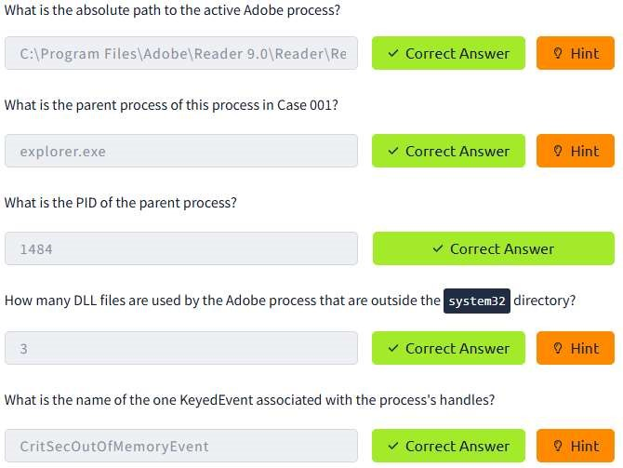

Task 5 : Volatility Hunting and Detection Capabilities

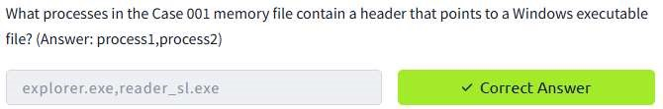

Task 6 : Advanced Memory Forensics

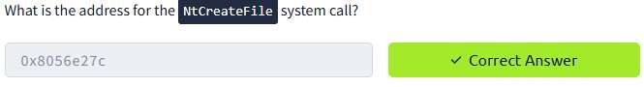

Task 7 : Practical Investigations

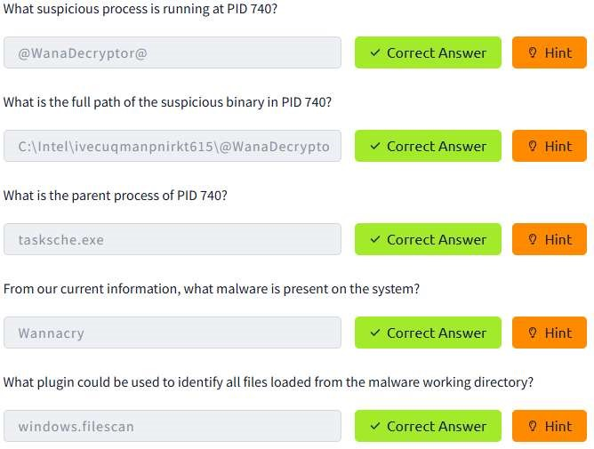

RESULT :

Memory Forensics with Volatality is successfullu completed in tryhackme platform